**Notes:**

* They like the Header from lhfs_demo_min.pdf
* They like the Navigation from lhfs_demo_min.pdf
* All other preferences come from lhfs_demo.pdf.
* We would prefer a separate container for the About Us Section and separate container for the Policy Group Types section instead of the two-column look.
* We would prefer the Policy Group Types section to be 4 across in-line. If it seems to be crowded, then do 2 columns of 2
* Pages below as navigation elements
* Page templates
  + Home
  + Everything else
    - Header
    - Navigation
    - White space for content
    - Footer

**PAGE: Home (Template 1)**

* Stacked
  + Photo
  + About Us (but cut it down some and have a “Read More”)
  + [Content Area with Tiles 4 wide like lhfs_demo.pdf]
    - Home (Clickable to page)
    - Auto (Clickable to page)
    - Specialty (Clickable to page)
    - Umbrella (Clickable to page)
  + Contact Us (replacing Existing Clients from lhfs_demo.pdf)
  + Proud to Endorse and Support (From lhfs_demo.pdf)
  + Footer (From lhfs_demo.pdf)

**PAGE: About Us (Template 2)**

Established in 2005, Land Home Financial Insurance Services is a wholly owned subsidiary of California-based Land Home Financial Services, Inc., a top 100 mortgage lender. The agency was originally established to efficiently provide mortgage division employees and their clients with competitively priced insurance options through reputable carriers. This would help streamline an integral step in the loan closing process. We have since developed into a full-service insurance agency operating in 13 states and growing. At Land Home Financial Insurance Services, we understand the importance of maintaining quality insurance coverage to safeguard you, your family and your way of life. As an independent agency, we will help you find and compare insurance coverage from some of the nation’s leading carriers. This means we are not bound by the restrictions of any one insurance carrier but instead quote with many carriers to find the right fit at the most competitive price. We offer a unique combination of knowledge and resources, while maintaining a friendly neighborhood agency atmosphere.

**PAGE: Homeowners (Template 2)**

*Sleep Secure Knowing Your Home is Properly Protected*

Your home is one of the most important financial and emotional investments of your life. It is where you sleep, raise a family and where you create lifelong memories. Your safe place! Make sure the foundation for your life is covered against those unexpected events. Homeowners insurance is also one of the most significant components in the closing of a home loan. Provide yourself with piece of mind by knowing your home and belongings are correctly covered, while ensuring your home loan closes on schedule.

-Homeowners Insurance – Primary or Secondary Residence

-Dwelling/Landlord Insurance – Residence You Rent to Others

-Condo Insurance

-Manufactured Home Insurance

-Renters Insurance – Residence You Rent for Yourself

Key Coverages to Consider Discounts Available

-Extended Dwelling Replacement Cost Coverage -Multi-Policy Discount

-Loss Assessment -Burglar/Fire Alarm Discount

-Building Ordinance or Law Coverage -Interior Fire Sprinkler System Discount

-Sewer & Water Backup Coverage -Accredited Builder Discount

-Identity Theft Coverage -Newly Acquired Home Discount

-Personal Injury Coverage -Loss Free Discount

-Equipment Breakdown Coverage -Gated/Secured Subdivision Discount

-Special Personal Property Coverage -Green Home Discount

-Increased Other Structures Coverage

-Valuable Articles (Scheduled Personal Property)

-Builders Risk/Theft of Building Materials

-Home Business Coverage

-Earthquake Coverage

**PAGE: Auto (Template 2)**

*Protection on The Road of Life*

For most us, our vehicles are our primary exposure to liability because we drive every day. You want a policy that will get you back on the road promptly and provide you with protection against legal and medical expenses resulting from an auto accident. Even with plenty of auto insurance providers to choose from, it can be very difficult obtaining the proper coverage for your specific situation, at the right price. Allow Land Home Financial Insurance Services to find the ideal auto insurance policy for you.

-Auto

-Classic Car

-Motorcycle

-RV

-SR22

Optional Coverages to Consider Discounts Available

-Rental Car Coverage/Reimbursement -Multi-Policy Discount

-Roadside Assistance -Loss/Claims Free Discount

-Glass Coverage -Multi-Car Discount

-Loan/Lease Payoff -Mature Driver Course Discount

-Custom Parts or Equipment Coverage -Driver Training Course Discount

-OEM Parts Replacement -Good Student Discount

-New Car Replacement -Distant Student Discount

-Ridesharing Coverage -Anti-Theft Discount

-Certified Mileage Program Discount

-Low Mileage Discount

-Pay in Full/EFT Discount

-Telematics Monitoring Discount

**PAGE: Umbrella (Template 2)**

*Powerful Coverage for All Your Assets*

Umbrella insurance is excess liability coverage. It is designed to cover you when the liability limits on your home or auto policies have been met. Take some time to review your assets with a Land Home Financial Insurance Services agent to see if you should have supplemental liability coverage to shield you and your family from the unthinkable.

Not sure if you should have an Umbrella policy? Does the total value of all your combined assets exceed the Liability Coverage amount on your auto or homeowners insurance policy? If you answered yes to this question, you should have an Umbrella policy to ensure you are properly protected.

Assets to Consider

-Home

-Land/Real Estate

-Autos

-Deposit Accounts

-Investment Accounts

-Retirement Accounts

-Cash

-Jewelry/Artwork/Collectibles

**PAGE: Specialty (Template 2)**

*Coverage for Your Toys and Other Unique Items*

* Personal Articles Floater - Jewelry, furs, fine arts, firearms and collectibles
* Motorcycle
* RV
* Travel Trailer
* Utility Trailer
* ATV
* UTV
* Golf Cart
* Snowmobile
* Boat/Jet Ski

**PAGE: Disclaimer (Template 2)**

**PAGE: Privacy Policy (Template 2)**

**Existing Clients (this likely will just be contact us content container)**

Have Questions on an Existing Policy? Call us at 1 (800) 678-6653 or email us at [insurance@lhfs.com](mailto:insurance@lhfs.com)

Get Documents- EZLynx feature that allows customers to print documents from our website.

Need to File a Claim?

Need to Make a Payment?

Bundle Coverage & Save- “Request a Quote” button/link

**Template 1**









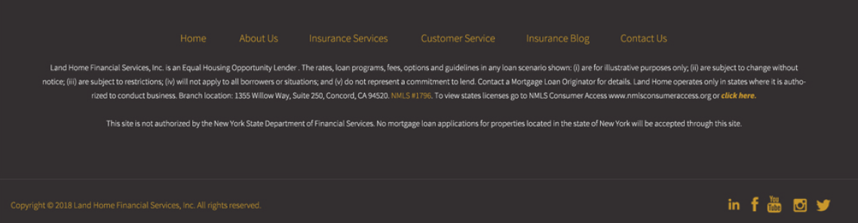

**Template 2**



**CONTENT HERE**



